NOS Report

- Student: Issam Abdullah Awamleh
- Company: JODDB
- URN of NOS: TECIS610501
- Name of NOS: Manage intrusion detection and analysis

**Performance criteria of the NOS and how you applied it in your company **
(Explain and include evidence from your work)
P1 – create the intrusion detection policy that identifies key stakeholders and their responsibilities in maintaining organisational governance for intrusion detection
I contributed to defining intrusion detection objectives within the SOC environment by supporting policies that govern acceptable and unacceptable website usage during Armython, including the monitoring of DNS and HTTP traffic. Ahmad tells us to block any AI site that has a chat so me and the team try to put in a list.
This included defining responsibilities between SOC analysts, SOC management, and incident response teams that will be in Armython when policy violations (such as unauthorised AI chatbot usage) are detected.
Here’ s the list of the websites that the SOC should block: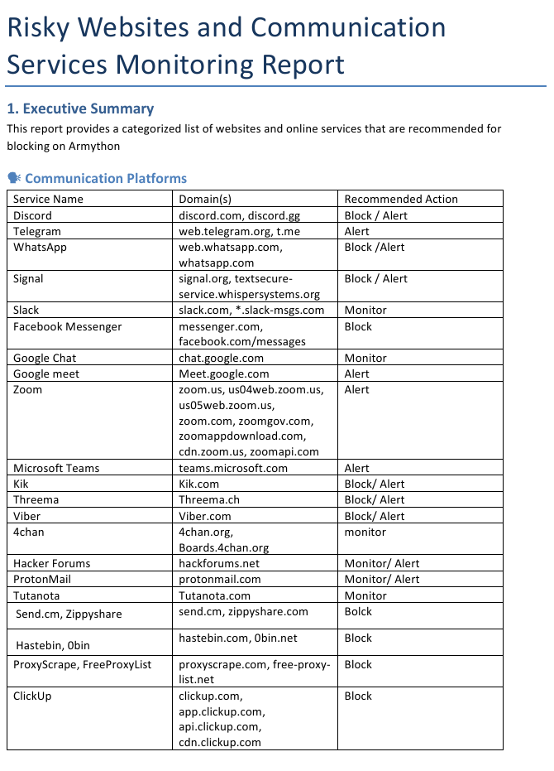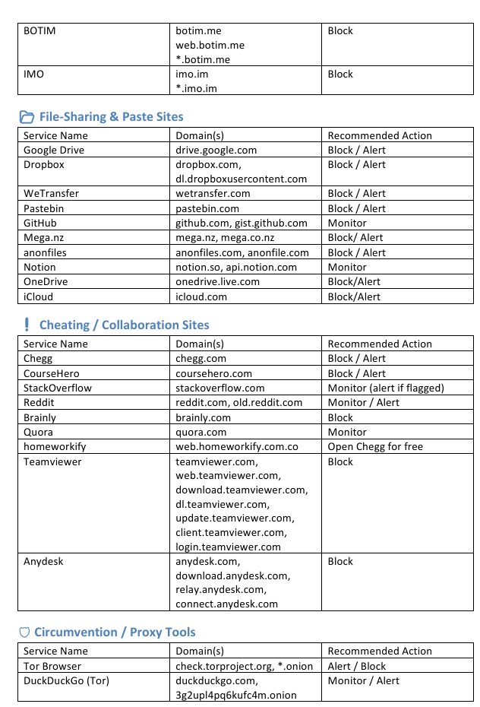 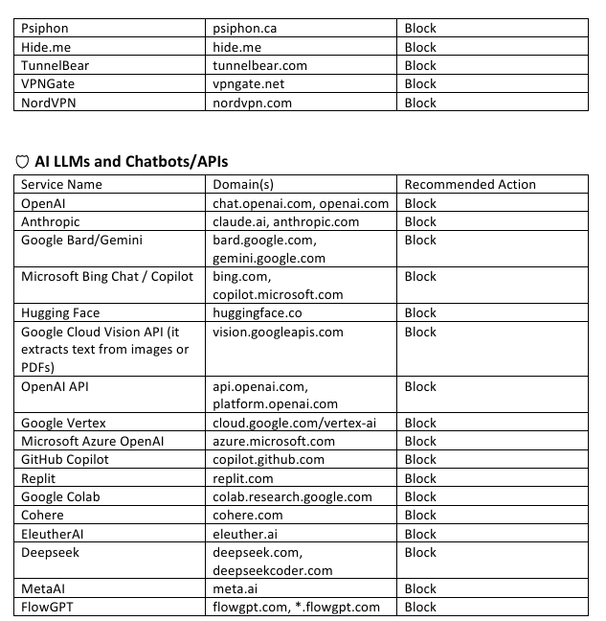
After transferring it from the policy to suricata rules(DNS,HTTP traffc tracking) :
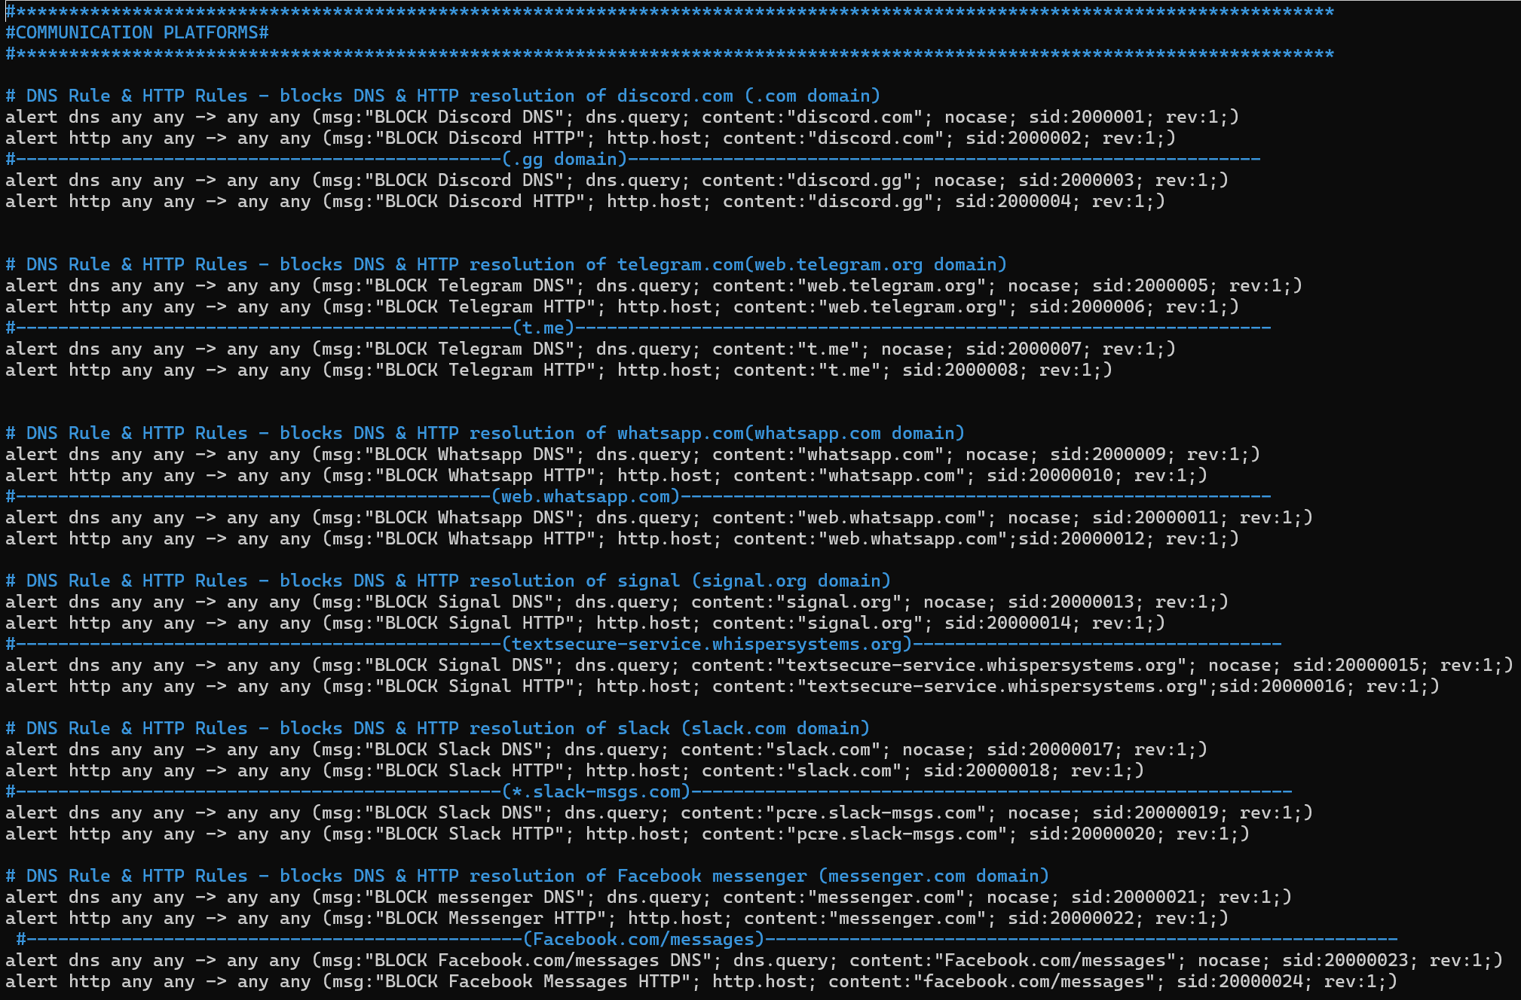

P2 – develop, review and maintain intrusion detection procedures that define the step-by-step sequence of activities required.
I developed and followed step-by-step intrusion detection procedures for monitoring and analyzing DNS and HTTP traffic using Suricata.
These procedures defined how alerts related to suspicious web activity (such as AI chatbot usage during the CTF) are identified, validated, escalated, and documented. And I develop the Suricata rules to detect many format of the AI URL links. I maintain it by keep testing it to see the efficiency of it by detect the traffic capturing from a single interface.
Here’s the alert of the SOC
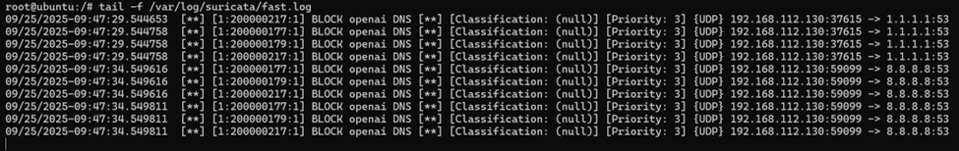

P3 – promote wide awareness and understanding of intrusion detection and incidents across the organization.
I promoted awareness of intrusion detection by explaining by quick presenttions to team members in my daily follow up for my task in this part in how DNS and HTTP monitoring can be used to detect policy violations and suspicious behavior.
The Armython CTF scenario was used to demonstrate how Suricata alerts help identify unauthorized external services, such as AI chatbot platforms.

Show the team leader and the rest of the team the result of capturing the traffic and the alert, Suricata saved the logs in 2 different files one of them is details and the second one is briefly and well organized.
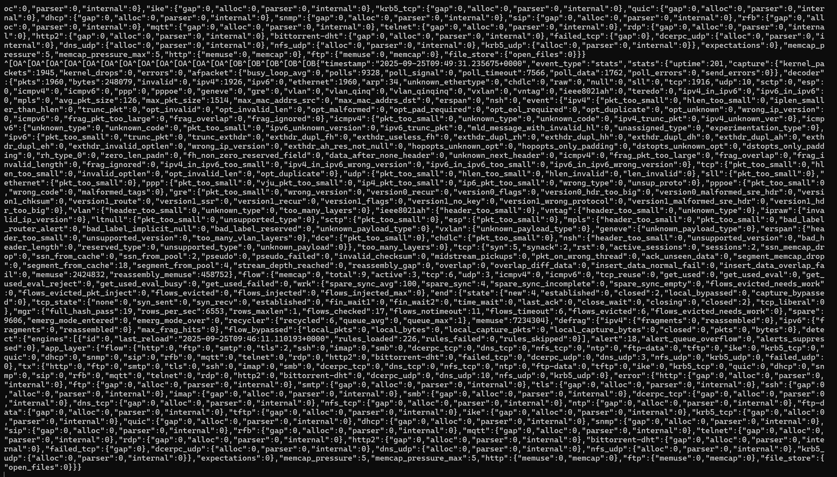


P4 – manage the intrusion detection and analysis function within an organization in order to deliver the required intrusion detection capabilities
I supported the management of the intrusion detection function by ensuring Suricata was correctly configured to monitor DNS and HTTP traffic and generate actionable alerts.
I ensured alerts were reviewed and aligned with the objectives of the SOC monitoring use cases defined for the CTF environment.
Here’s the some proof of managing the intrusion Detection:
- Suricata configuration files
- SOC monitoring dashboards
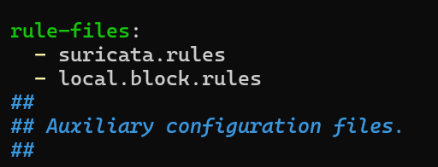
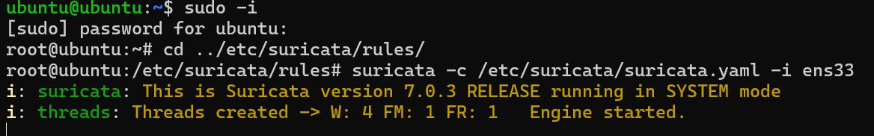
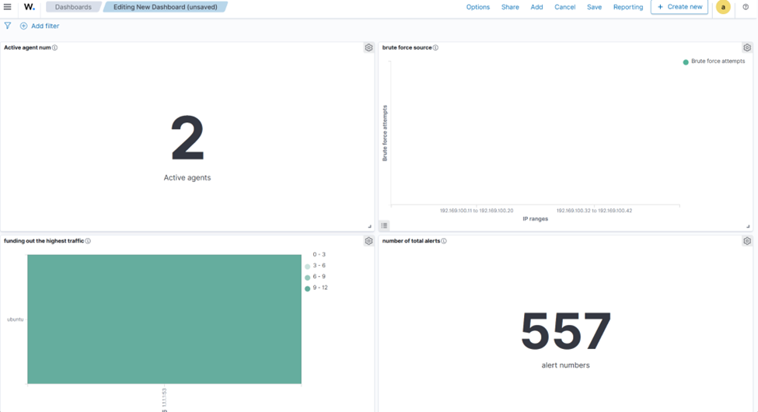

P5 – lead and oversee intrusion detection activities ensuring intrusion detection and analysis teams deliver intrusion management objectives.
I assisted in overseeing intrusion detection activities by reviewing Suricata alerts related to DNS queries and HTTP requests and ensuring they were investigated appropriately. Also do daily test cases to make sure that the rules is set perfectly.
I supported prioritization of alerts based on policy relevance and potential security impact.
Here’s alert review from the log file of the Suricata. 

P6 – review and identify gaps in intrusion detection capabilities in order to continuously improve intrusion monitoring and detection and plan resource and training needs.
during the daily test cases I found out there’s some AI chat sites didn’t added so I add to the list and send it to the team leader.
I reviewed Suricata alert output during the Armython CTF to identify gaps such as missed detections or excessive false positives.
Based on this review, I recommended improvements to detection logic and analyst awareness for better visibility of unauthorized web services.
Here’s some the websites that had been added:
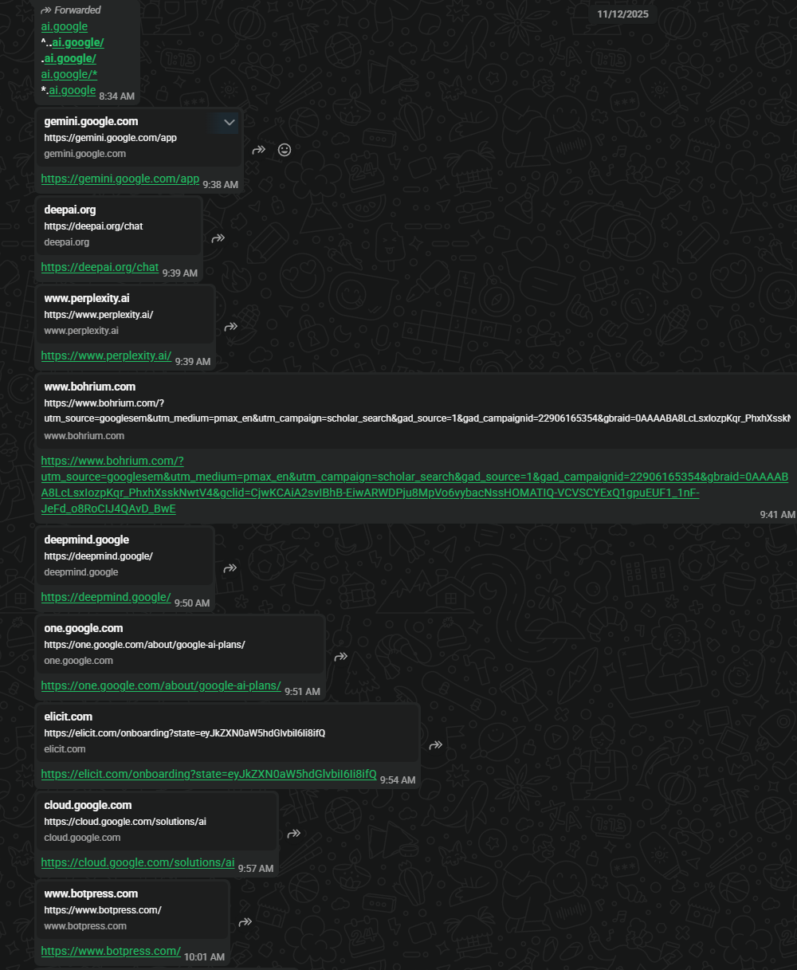
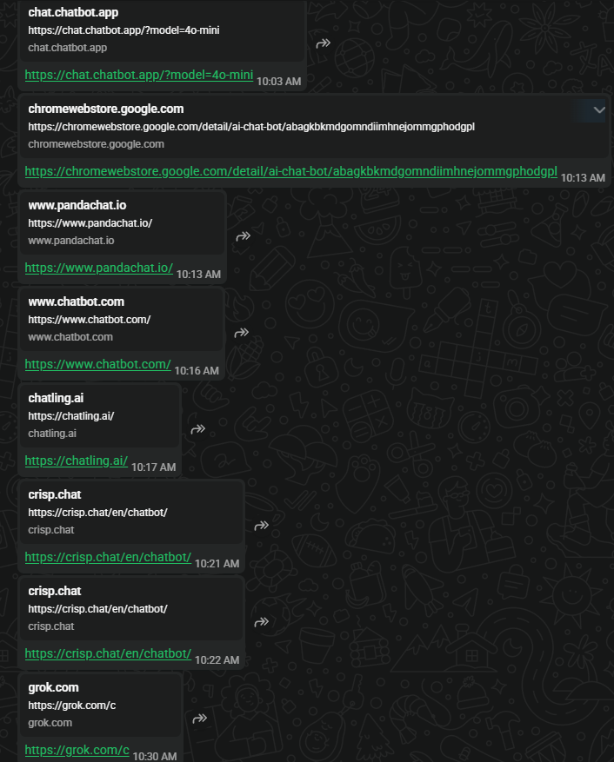

P7 – create new signatures and rules to improve detection of malicious activit.
I created and modified Suricata rules to detect DNS queries and HTTP requests in large range by adding the extra sites associated with AI chatbot services.
These custom rules enabled the SOC to generate alerts when participants attempted to access AI tools during the CTF, supporting policy enforcement and behavioural monitoring.
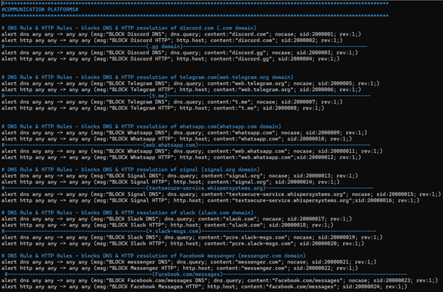
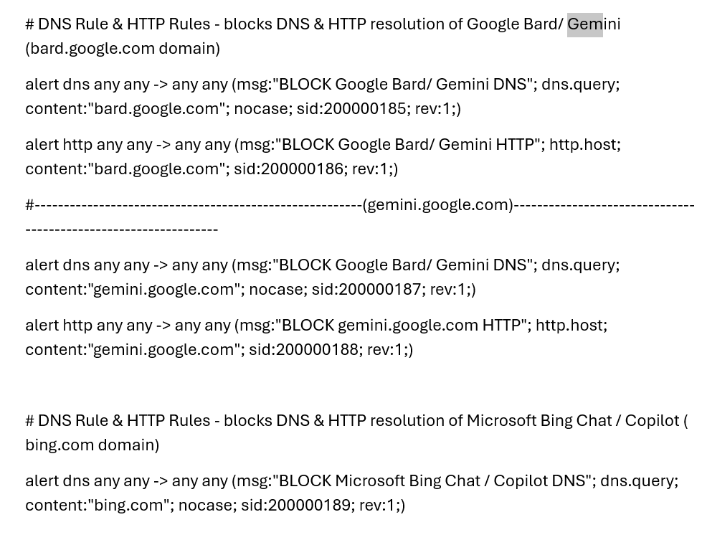


P8 – define and implement base metrics to review and measure the intrusion detection process
These already happened in daily test cases also I supported the use of metrics such as the number of AI-related alerts, alert accuracy, and response time to evaluate the effectiveness of the detection rules.
These metrics were used to assess detection quality and guide further tuning.
Here’s the metrics dashboard:
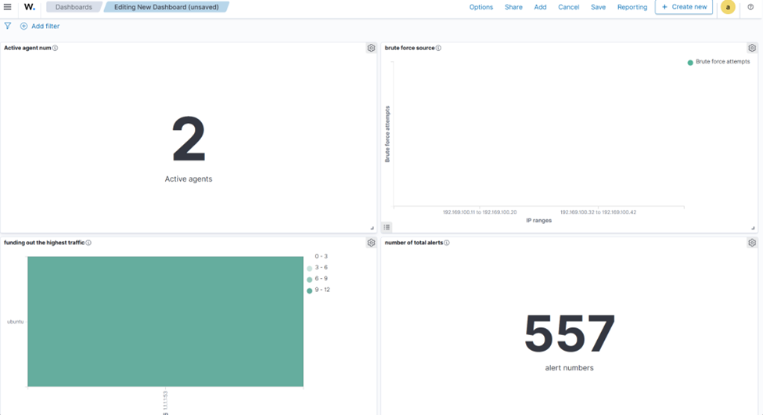

- P9 – coordinate the delivery of intrusion detection and 24/7 protective monitoring
I contributed to ensuring continuous monitoring by maintaining Suricata alerting throughout the CTF exercise and supporting consistent review of alerts during active monitoring periods.
And the team of the SOC ,technical and the incident response teams was ready during Armython .

P10 – advise senior business management on intrusion detection and analysis capabilities and resource requirements
I contributed to reporting on the effectiveness of DNS and HTTP-based detection and explained how these capabilities can be extended to enforce organizational policies in real-world environments.
Also after I finished the rule the intrusion detection, I recommend that should have intrusion prevention to block not only alert so that was the functionality of the firewall.

P11 – communicate intrusion incidents, trends and recommendations for improving intrusion detection capabilities
I communicated findings related to repeated AI chatbot access attempts and identified behavioural trends during the CTF. I was part of the SOC team we wrote a report about the team who used AI.
I provided recommendations on improving detection logic and awareness controls.
I recommend them also to block MCP(AI agent already download it in the competitor) but we didn’t have the way of implement it.

P12 – escalate declared incidents with incident management and forensic teams
When alerts indicated repeated or deliberate policy violations, I followed defined escalation procedures to notify team leader SOC personnel for further action. Also the escalation of any problem that happened in the test period before Armython.
P13 – define and document intrusion detection and analysis team roles and responsibilities to meet organisational requirements.
I supported documentation that defined analyst responsibilities for monitoring, analysing, and responding to Suricata alerts generated from DNS and HTTP traffic.
My role was monitoring the SOC and write report of the significant events any problem I would face I was telling the team leader Ala’a

P14 – promote wide awareness and understanding of what’s involved in intrusion detection and the implications in different areas of the organization
I used the AI chatbot detection use case to explain how network monitoring supports policy enforcement, fairness, and security, and how similar techniques apply to real organizational environments. That was after Armython in meeting for evaluate Armython.

